International Multidisciplinary Journal of Technologies and Applications (IMJETA)
Vol. 1, No. 1, pp. a-b, Month 2026
Received Month 00, 2026; Revised Month 00, 2026; Accepted Month 00, 2026
Published Month 00 2026

Evaluation of Spatial SQL Injection Vulnerabilities in PostGIS-Based Cadastral Information Systems

Rodrigo A. Becerra Lucano^{1[0009-0006-4988-1349]} and Manuel J. Ibarra-Cabrera^{2[0000-0001-6711-4916]}
¹Escuela de Posgrado, Doctorado en Ciencias de la Computación, Universidad Nacional del Altiplano, Puno, Perú
74761925@epg.unap.edu.pe
²Departamento Académico de Informática y Sistemas, Universidad Nacional Micaela Bastidas de Apurímac, Abancay, Perú
mibarra@unamba.edu.pe

Abstract. The incorporation of spatial databases into web architectures has expanded the attack surface for modern applications; however, the risks associated with spatial SQL injections remain underexplored. This article investigates the exploitation and mitigation of spatial SQL injections within cadastral information systems that use PostGIS. A containerized testbed environment was developed, using Docker, to simulate an infrastructure API built with Python (FastAPI) and PostgreSQL / PostGIS. The study demonstrates how attackers can leverage spatial functions (ST_DWithin, ST_Intersects) to manipulate geospatial logic, extract unauthorized zoning data, or induce denial of service states. Furthermore, the research evaluates the impact on performance when implementing robust mitigation strategies, comparing vulnerable dynamic spatial queries with parameterized queries executed through Object-Relational Mapping (ORM) tools such as SQLAlchemy and GeoAlchemy2. The results indicate that the proposed pipeline neutralized 100% of the attack vectors with an average latency overhead of 2.63 ms (+15.24%) and a 12.59% improvement in tail stability (p99). It is concluded that effective mitigation of spatial injections relies on transferring topological validation and rigid parametrization to the application layer (ORM), ensuring cadastral integrity with marginal operational impact.

Keywords: Cadastral Systems, Cybersecurity, PostGIS, Spatial SQL Injection

- Introduction
Modern cadastral information systems expose web services and geoportals over client-server architectures to administer land tenure, urban zoning, and tax collection (Lemmen el al., 2015). In this field, PostgreSQL along with its PostGIS spatial extension constitutes the most widely used open-source solution for the persistence and querying of official vector cartography (Obe & Hsu, 2021).

However, exposing these services through REST APIs introduces attack vectors when queries are constructed via string concatenation within spatial functions. While classical SQL injection has been widely documented (Clarke, 2012; Halfond et al., 2006; OWASP Foundation, 2021), the manipulation of PostGIS geometric operators – such as ST_DWithin, ST_Intersects, or ST_Buffer – presents little-addressed specificities: unsanitized input not only allow bypassing relational filters or exfiltrating data, but also triggering denial of service states though topological calculations with high algorithmic complexity.

This article presents an experimental evaluation of spatial SQL injection vulnerabilities in PostGIS-based cadastral information systems. The study: (1) documents and evaluates six attack vectors oriented to the CIA triad (Confidentiality, Integrity, and Availability); (2) implements a reproducible testbed on a dataset of 487 urban parcels structured under the ISO 19152 (LADM) standard; and (3) quantifies the impact on latency and throughput of a mitigation architecture based on typed ORGM compilation (GeoAlchemy2) and prior validation with Shapely and Pydantic.

- Related Work

  - SQL Injection in Spatial Engines and Topological Operators
The foundational literature in computer security has established robust classifications for SQL injection attacks. Halfond et al. (2006) classified these attacks into tautologies, union queries, blind injections, and stored procedure piggybacking. Clarke (2012) deepened the analysis of abstract syntax trees (AST) generated by database parsers when concatenating unsanitized parameters. However, these frameworks do not take into account the way spatial algebraic operators (Egenhofer, 1994) redefine logical evaluation conditions. Unlike a simple scalar value, a geometric expression processes multiple dimensions, spatial reference systems (SRID), and minimum, bounding boxes, which expands the syntactic escape area. This theoretical gap in traditional injection models leaves the manipulation of native topological predicates in relational engines uncharacterized.

  - Access Control Models and Geospatial Inference Breaches
Access control in spatial databases was formally conceptualized by Bertino et al. (2005) though the GEO-RBAC (Spatially Aware Role-Based Access Control) model, which demonstrated that read and modification privileges must be subordinated to dynamic geographic boundaries. Complementarily, Chun and Atluri (2008) analyzed spatial inference risks in SDBMS, where an unauthorized user can deduce the existence or attributes of a protected object by correlating successive spatial queries. However, these approaches assume that the service layer accurately transfers spatial policies to the database; in modern web architectures, insecure concatenation directly overrides persistence access control without being detected by application layer authorization mechanisms.

  - Cadastral Integrity and Data Modeling under the LADM Standard
The ISO 19152:2012 standard, also known as the Land Administration Domain Model (LADM), regulates the technical modelling of cadastral information systems globally. Reference authors such as Lemmen et al. (2015) and van Oosterom et al. (2006) formalized the fundamental cadastral classes, highlighting LA_SpatialUnit (parcels and lots) and LA_Party (property owners), later extended to automated mass valuation models (Kara et al., 2021). Although the standard prescribes the semantics and interoperability of territorial and registry information, it does not define query-level architectural safeguards against SQL injection attacks, leaving the integrity of property rights and tax collection exposed to software implementation flaws.

  - Algorithmic Complexity Attacks and Vulnerabilities in OGC Services
The current relevance of this threat was demonstrated in the industry by the critical vulnerability CVE-2023-25157 (with a CVSS score of 9.8), where the reference software GeoServer allowed unauthenticated remote SQL execution through the insecure evaluation of OGC filters and CQL expressions over PostGIS databases (National Vulnerability Database, 2023). On the other hand, in the scope of denial of services, Crosby and Wallach (2003) established the concept of Algorithmic Complexity Attacks, demonstrating ow crafted inputs can force worst-case algorithms (O(N^2)) to monopolize the CPU. In spatial engines, according to Agarwal and Rajan (2016), the computational algorithms of the GEOS library, integrated into PostGIS, demand quadratic computational overhead when executed on complex polygons without preliminary filtering by GiST spatial index. Despite these precedents, the literature has neither measured the latency impact nor formalized integrated defensive schemes between the web parser and the geometric engine.

- Methodology

  - Approach and Experimental Design
A quantitative experimental design was adopted to determine the vulnerability of geospatial endpoints to SQL injections and measure the performance impact resulting from a multilayer mitigation scheme. The evaluation considers two conditions: queries with unprotected dynamic SQL and queries compiled via ORM with prior geometry validation.

  - Cadastral Dataset
The experimental dataset comprises 1,500 contiguous urban cadastral parcels structured under the ISO 19152 standard (LADM, class LA_SpatialUnit) and georeferenced in EPSG:32719. To ensure reproducibility and ethical safeguarding, the base cartography was obtained from open sources and fiscal attributes were procedurally generated without including real personal information.

  - Experimental Environment and Architecture
The testbed was implemented in Docker containers using isolated microservices: (1) a database service with PostgreSQL 15 and PostGIS 3.3, and (2) an API in Python 3.11 with FastAPI and Uvicorn. Stress tests were executed in a controlled environment with an Intel Core Ultra 5 245KF processor of 14 cores at 5.2 GHz with 32 GB DDR RAM and NVME PCIe 4.0 storage on Linux kernel 6.6 (WSL2). Source code, dataset, and the interactive playground are publicly available at: https://github.com/RAlexander777/Playground-SQLi-PostGIS.git

  - Test Vectors and Performance Metrics
Six exploitation vectors were structured based on the injection testing guidelines of the Web Security Testing Guide (OWASP Foundation, 2023), oriented to the three dimensions of the CIA triad (Confidentiality, Integrity, and Availability). The experimental battery comprised two categories of vectors: (a) direct spatial injection vectors (V1 to V3), targeted against native topological predicates and geometric analysis functions in PostGIS; and (b) conventional SQL injection vectors applied to the transactional and administrative workflow of the cadastre (V4 to V6), used as a baseline control to verify data model integrity and transactional control flow. The performance evaluation included a load of 300 requests and stepped concurrency curves (1 to 100 clients), recording latency metrics (mean, p50, p95, p99) and throughput (req/s). The technical characterization of the six exploitation vectors, their endpoints, and representative payloads are detailed in Appendix 1.

- Attack Simulations and Exploitation Results

  - Simulation 1: Spatial Boundary Bypass (Spatial Logic Bypass)
The endpoint GET /api/v1/vulnerable/predios/radio is designed to return parcels within a 50-meter radius in sector 0101. By injecting the payload: ’50) OR (1=1’ into the distance parameter, the PostgreSQL lexical analyzer prematurely closes the ST_DWithin operator and introduces a tautology that nullifies both the spatial boundary and the territorial sector filter. As a result, the query went from returning 1 authorized parcel to massively return 50 unauthorized cadastral parcels in 7.03 ms. In the mitigated endpoint, Pydantic and GeoAlchemy2 verified strict numeric typing, neutralizing the attack with HTTP status code 422.

  - Simulation 2: Data Inference through Geometric Errors (Error Based Spatial SQLi)
In the endpoint GET /api/v1/vulnerable/predios/poligono, the application draws cartographic polygons without exposing textual data. The attacker structured an inferential side channel coupled to the ST_Intersects operator, injecting a division by zero conditional on character guessing against the administrative table: if the guessed character matches, an exception occurs in PostGIS triggering an HTTP 500 error; if false, the engine responds with HTTP 200. Through this mechanism, the complete credential ‘admin’ was obtained in 42 seconds. In the mitigated version, Shapely evaluated topological validity in memory, rejecting the syntax with HTTP 422.

  - Simulation 3: Spatial Denial of Service (Spatial DoS)
Leveraging the baseline geometric complexity of the parcels (average of 9.0 vertices and up to 222 vertices per polygon), the attacker injected a subquery with an O(N^2) spatial cross product into the endpoint GET /api/v1/vulnerable/predios/analisis-expansion that computes buffers with high segment density per quadrant. The injection evaluated a systematic subset of 20 parcels combined via a Cartesian product (400 polygon pairs), varying the vertex resolution of the buffer. As evidenced in Figure 1, the injection of the Cartesian product triggers an O(N^2) algorithmic complexity explosion that raises latency from 10.8 ms up to 1,692.1 ms as evaluated buffer vertices grow form 14,400 to over 345,600 points, saturating PostgreSQL workers on the Intel Core Ultra 5 245KF processor. Conversely, the mitigated architecture preserves a bounded latency of ~15 ms by constraining parameters to validated scalars using Pydantic and GeoAlchemy2.

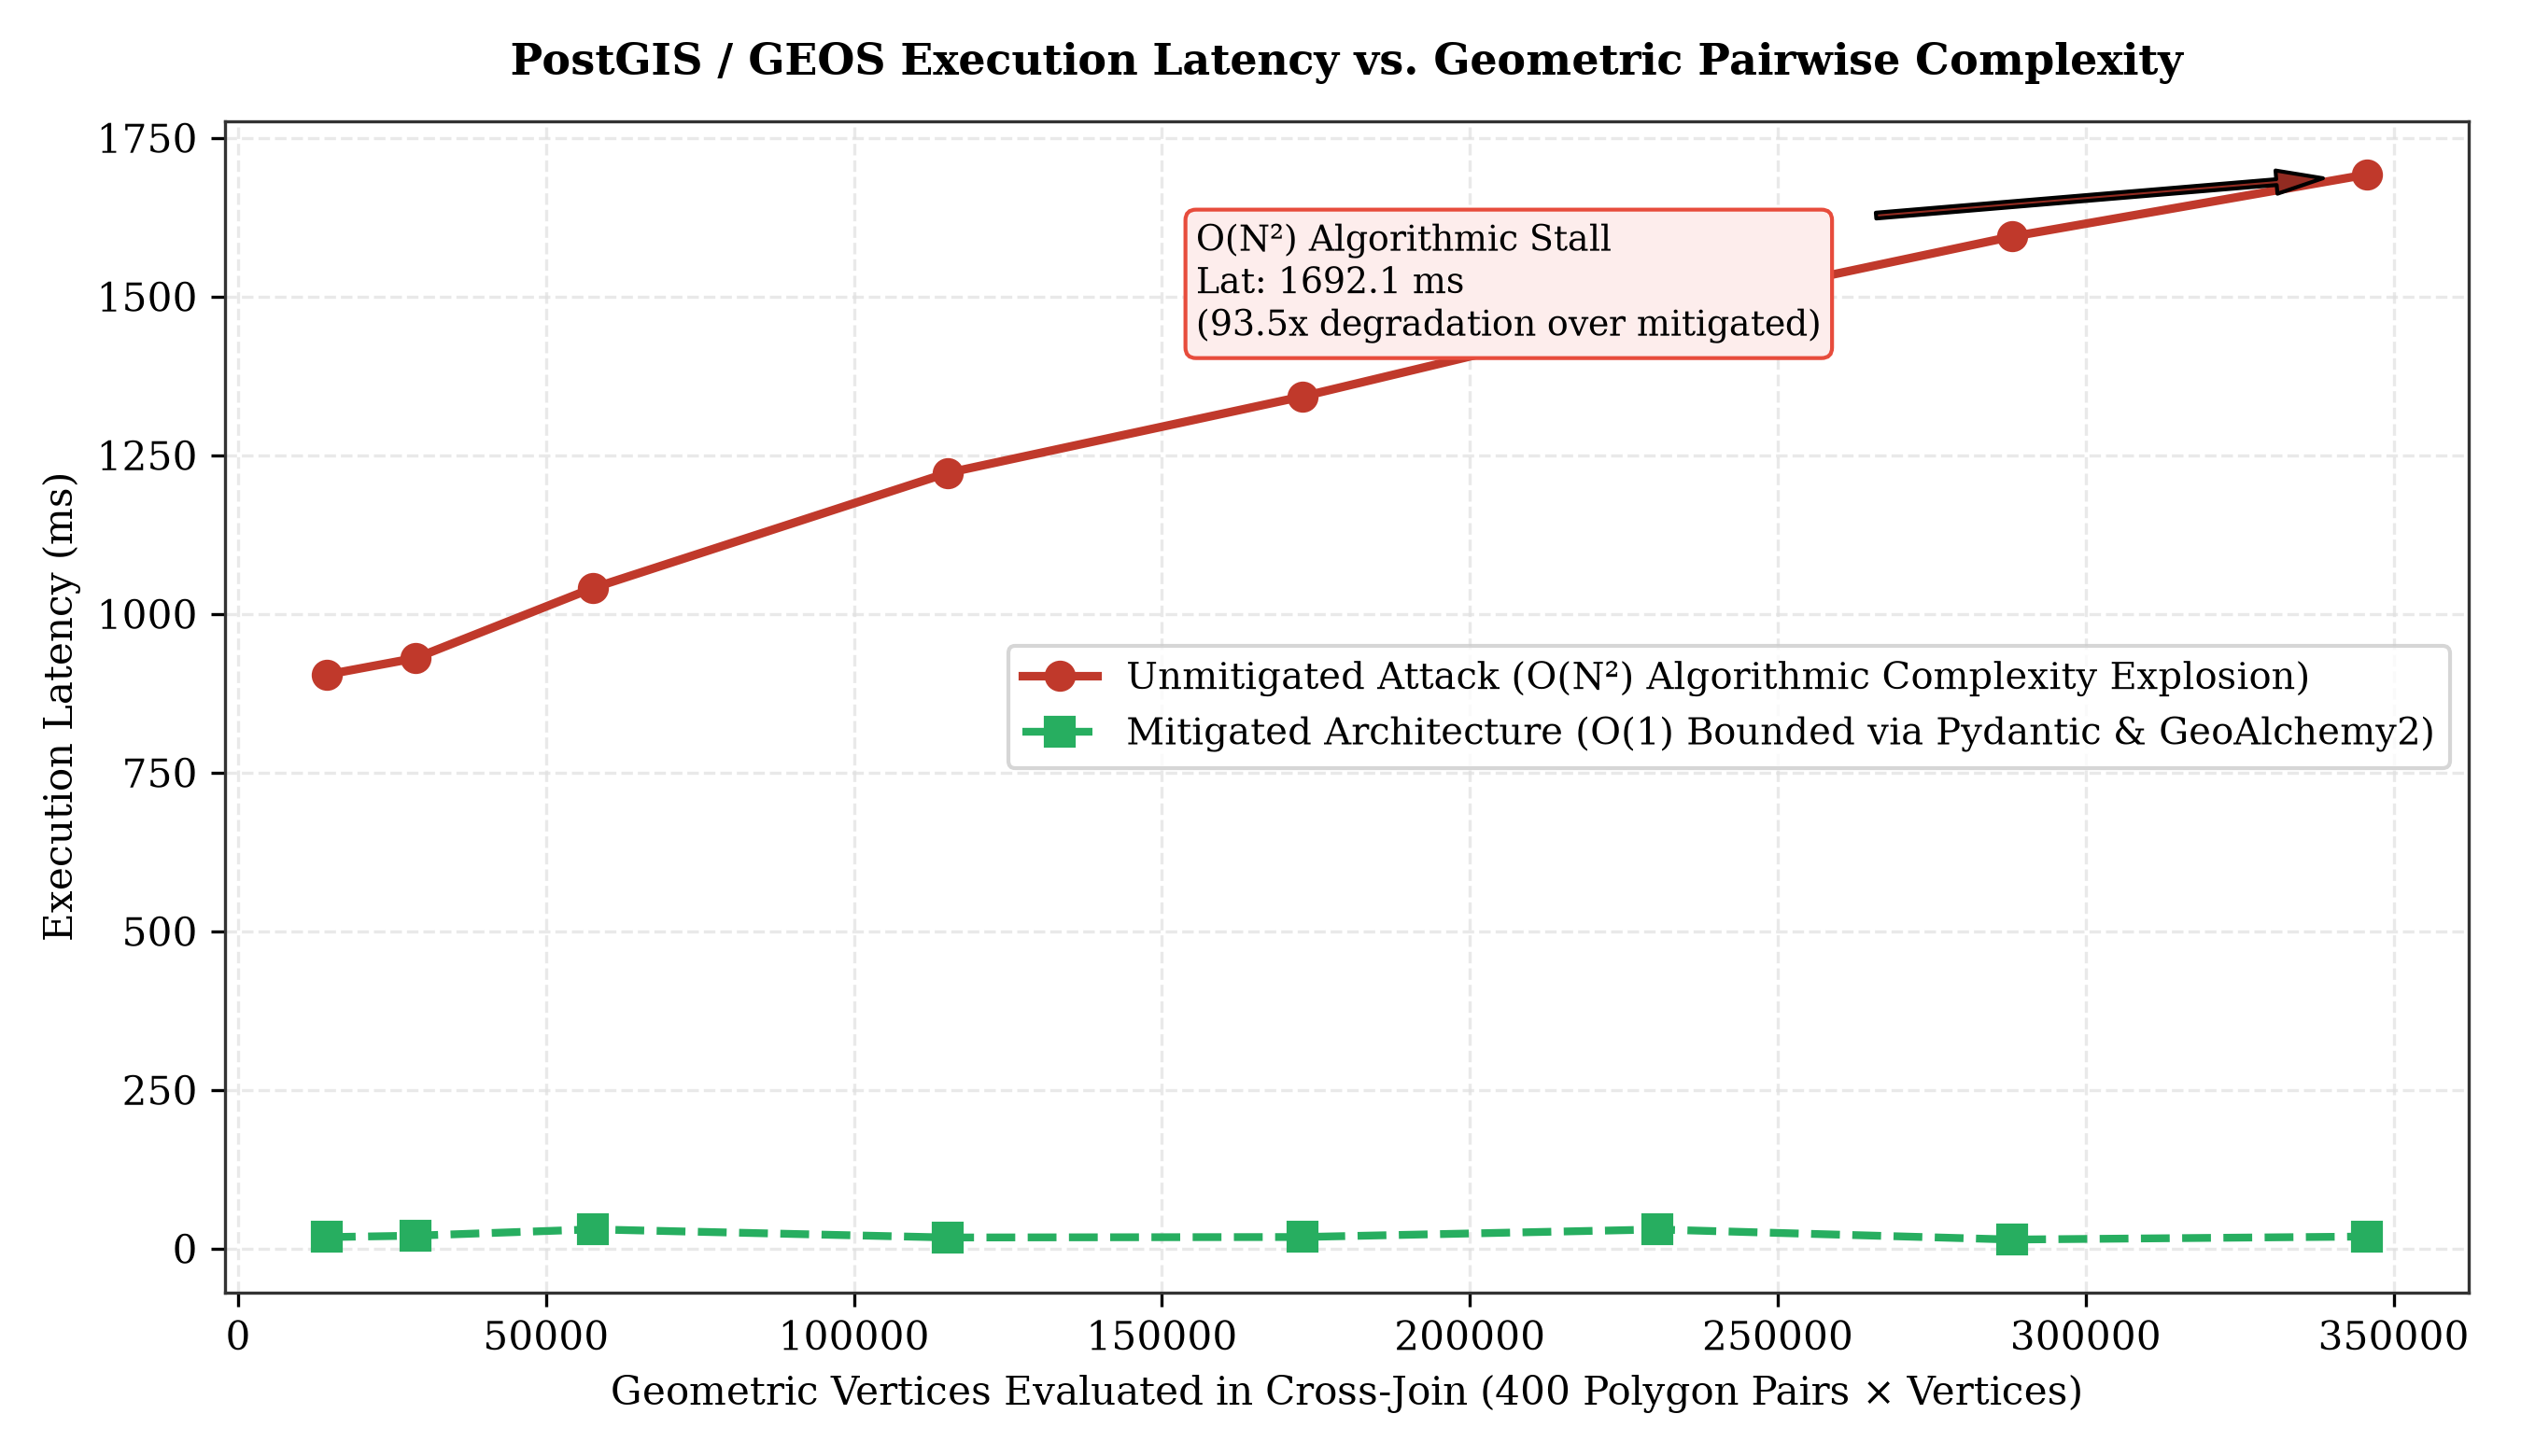
Figure 1. Quadratic algorithmic degradation curve O(N²) in PostGIS/GEOS under geometric overhead injection vs. bounded mitigation

  - Simulation 4: Cadastral Record Fraud (Property Tax Assessment Tampering)
In the endpoint POST /api/v1/vulnerable/fiche/modificar, an attack against data integrity was simulated. Through concatenation in the SET clause, the attacker manipulated the tax assessment setting it to S/ 0.00 and replaced the legitimate property owner with an unauthorized third party, demonstrating the vulnerability of fiscal databases to direct update injections. The mitigated endpoint blocked the fraud using alphabetic regular expressions and positive range validation in SQLAlchemy (HTTP 422).

  - Simulation 5: Destructive Deletion of Cadastral Cartography (Data Destruction)
In the endpoint DELETE /api/v1/vulnerable/predios/borrar, injecting the literal payload ‘0101’ OR ‘1’=’1’ into the sector filtering parameter transformed the statement into an unconditional deletion of records (DELETE FROM tg_lote WHERE cod_sector = ‘0101’ OR ‘1’=’1’), deleting all 1,500 parcels and leaving the webmapping viewer without cartography. In contrast, the mitigated endpoint validated the sector using the strict pattern ^\d{4}$, rejecting the injection with HTTP code 422 and preserving the cadastral database.

  - Simulation 6: Authentication Bypass in the Cadastral Viewer
In the endpoint POST /api/v1/vulnerable/auth/login, the attacker entered “admin’--“ into the username field, commenting out the password hash validation. The API granted access and issued a token with the role superadmin_catastro. The mitigated version with prepared statements and SHA-256 cryptographic hashing neutralized the bypass by searching literally for the string with quotes without interpreting it as SQL syntax.

- Mitigation Strategies and Performance Evaluation
As illustrated in Figure 2, the architectural mitigation integrated a defense-in-depth pipeline with three sequencial barriers: where Barrier 2 (Shapely) operates as an in-memory topological integrity filter activated specifically for complex geometric payloads (WKT or GeoJSON, discarding anomalies or self-intersecting geometries with HTTP 422 before interacting with the database), while purely numerical or alphanumeric parameters transit directly from strict Pydantic validation (Barrier 1) to compiled typed variables (EWKB) and prepared statements in GeoAlchemy2 and SQLAlchemy (Barrier 3).

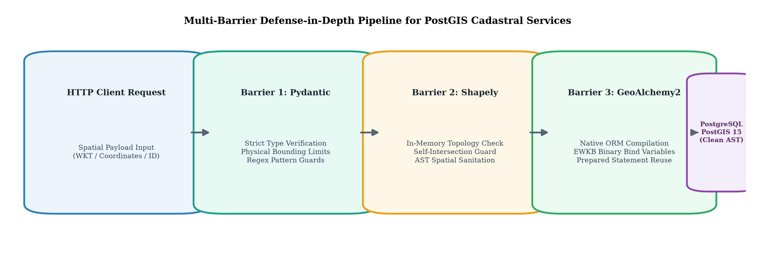
Figure 2. Architecture of the three-barrier defense-in-depth pipeline for cadastral services in PostGIS

For the empirical performance and latency evaluation (Table 1 and Figure 3), the spatial query by radius endpoint (GET /api/v1/vulnerable/predios/radio vs. GET /api/v1/mitigated/predios/radio) was selected as a representative high-frequency transactional scenario, evaluating valid requests under a standardized load of 300 requests with 10 concurrent clients. The results are summarized in Table 1.

Table 1: Performance and Latency Comparison between Vulnerable API and Mitigated API

Performance Metric | Vulnerable API (Dynamic SQL) | Mitigated API (GeoAlchemy2) | Variation (Overhead)
Throughput | 556.21 req/s | 484.36 req/s | -71.85 req/s (-12.92%)
Mean Latency | 17.26 ms | 19.89 ms | +2.63 ms (+15.24%)
50th Percentile (Median / p50) | 15.37 ms | 18.42 ms | +3.05 ms
95th Percentile (p95) | 31.49 ms | 32.63 ms | +1.14 ms
99th Percentile (p99) | 43.75 ms | 38.24 ms | -5.51 ms (-12.59%)
Failure Rate | 0.0% | 0.0% | 0.0%

To measure resilience under progressive stress, a stepped concurrency series of 1 to 100 clients was evaluated. As evidenced in Figure 3(a), the throughput of the mitigated architecture scales efficiently, reaching a stable plateau exceeding 450 req/s without degradation due to locks. Likewise, Figure 3(b) reveals that the mitigated architecture neutralizes the severe tail latency spikes observed in the vulnerable API under low concurrency (140.8 ms vs. 33.1 ms at 5 clients). Under high stress levels (50 to 100 clients), the 99th percentile of the mitigated version experiences a moderate increase (~101 ms vs. ~62 ms), attributable to serialization and CPU overhead in the application layer (Pydantic/ORM), representing an acceptable trade-off for the security guarantees obtained.
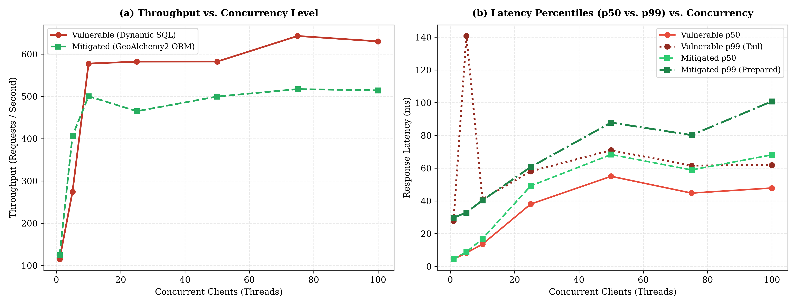

Figure 3. Empirical comparison of performance (Throughput) and latency percentiles (p50 and p99) under stepped concurrency (1 to 100 clients)

- Discussion
The experimental test results demonstrate that the proposed architecture (GeoAlchemy2 alongside prior validation in Shapely) introduces an average latency overhead of 2.63 ms per request (+15.24%), maintaining a processing rate of 484.36 req/s. A relevant aspect for software design is the behavior at the 99th percentile (p99): tail latency decreased form 43.75 ms to 38.24 ms, representing a 12.59% improvement
In service stability. This optimization is due to PostgreSQL reusing in-memory execution plans (prepared statements), eliminating the recurring cost of re-parsing dynamic queries syntactically.

This average overhead is acceptable given the protection guarantees obtained: it neutralizes massive parcel leakage, error-based side channels, and denial of service. In contrast to the unprotected vulnerable architecture (where 100% of the attacks succeed), the three-barrier pipeline implemented at the application layer achieved a 100% mitigation rate across all evaluated vectors of the CIA triad.

Platform independence and benchmarking validity. Although absolute latency values depend on the baseline test hardware, the methodological validity and generalizability of the results reside in the relative proportions (+15.24% average overhead and -12.59% improvement in p99) and asymptotic complexities. On municipal servers or cloud instances with constrained resources, the computational consumption of prior validation in Python (GeoAlchemy2 and Shapely) is marginal compared to disk access latency and relational concurrency. Conversely, omitting mitigation against quadratic complexity attacks (O(N^2)), such as spatial DoS (Simulation 3), exposes processors with lower parallelism to immediate saturation, where a small number of malicious requests completely locks the cadastral geoportal.

Systemic impact on the integrity of cadastral procedures and data. The feasibility of fraud in property tax assessments and ownership (Simulation 4) demonstrates that an injection in the persistence layer transcends the modification of an isolated table and compromises property information. Currently, geoportals interoperate autonomously to issue cadastral certificates with QR codes, tax clearance certificates, and property transfers under the ISO 19152 (LADM) standard. The injection of arbitrary data into catastro_titulares and tg_lote propagates legal and fiscal inconsistencies into these official documents without generating alerts in the user interface. This scenario confirms that strict typing in the ORM is an indispensable protection to preserve the legitimacy and traceability of digital public services.

- Conclusions and Recommendations

This article formalized and empirically demonstrated the viability of six spatial SQL injection vectors oriented to the CIA triad (Confidentiality, Integrity, and Availability) in PostGIS-based cadastral information systems, showing that native topological functions do not guarantee data isolation when constructed through string concatenation. The experimental evaluation on a dataset of 487 cadastral parcels structured under the ISO 19152 (LADM) standard verified that an attacker can bypass zonal boundaries, reconstruct credentials through geometric error side channels, induce denial of service through quadratic algorithmic overhead, alter property tax records, and execute bulk cartographic deletions. In response, the defense-in-depth architecture based on typed compilation through ORM (GeoAlchemy2), rigid typing with Pydantic, and prior topological validation in memory with Shapely successfully mitigated 100% of the evaluated exploitation scenarios. Transactional benchmarking demonstrated that this scheme introduces an average latency overhead of 2.63 ms (+15.24%), simultaneously improving stability at the 99th percentile by 12.59% thanks to the reuse of prepared execution plans in PostgreSQL. In conclusion, security in cadastral infrastructures requires abandoning the traditional scalar sanitization paradigm, adopting parameterization in the ORM and spatially aware syntactic controls integrated from the architectural software design.

- References

Agarwal, S., & Rajan, K. S. (2016). Performance analysis of MongoDB versus PostGIS/PostgreSQL databases for line intersection and point containment spatial queries. Spatial Information Research, 24(6), 669–677. https://doi.org/10.1007/s41324-016-0059-1
Atluri, V., & Chun, S. A. (2004). An authorization model for geospatial data. IEEE Transactions on Dependable and Secure Computing, 1(4), 238–254. https://doi.org/10.1109/TDSC.2004.34
Bertino, E., Catania, B., & Damiani, M. L. (2005). GEO-RBAC: A spatially aware RBAC. In Proceedings of the 10th ACM Symposium on Access Control Models and Technologies (SACMAT '05) (pp. 29–37). Association for Computing Machinery. https://doi.org/10.1145/1063979.1063985
Chun, S. A., & Atluri, V. (2008). Geospatial database security. In H. Chen, T. S. Raghu, R. Ramesh, R. Sharman, & S. Chakravarty (Eds.), Handbook of Database Security: Applications and Trends (pp. 251–277). Springer. https://doi.org/10.1007/978-0-387-48533-1_11
Clarke, J. (2012). SQL Injection Attacks and Defense (2nd ed.). Syngress / Elsevier.
Crosby, S. A., & Wallach, D. S. (2003). Denial of service via algorithmic complexity attacks. In Proceedings of the 12th USENIX Security Symposium (pp. 29–44). USENIX Association.
Egenhofer, M. J. (1994). Spatial SQL: A query and presentation language. IEEE Transactions on Knowledge and Data Engineering, 6(1), 86–95. https://doi.org/10.1109/69.273029
Halfond, W. G., Viegas, J., & Orso, A. (2006). A classification of SQL-injection attacks and countermeasures. In Proceedings of the IEEE International Symposium on Secure Software Engineering (ISSSE '06). IEEE.
Kara, A., Çağdaş, V., Isikdag, U., van Oosterom, P., Lemmen, C., & Stubkjær, E. (2021). Towards the LADM Valuation Information Model: A case study in Turkey. Land Use Policy, 109, 105658. https://doi.org/10.1016/j.landusepol.2021.105658
Lemmen, C., van Oosterom, P., & Bennett, R. (2015). The Land Administration Domain Model. Land Use Policy, 49, 535–545. https://doi.org/10.1016/j.landusepol.2015.01.014
National Vulnerability Database. (2023). CVE-2023-25157 Detail: GeoServer SQL Injection Vulnerability. National Institute of Standards and Technology. https://nvd.nist.gov/vuln/detail/CVE-2023-25157
Obe, R. O., & Hsu, L. S. (2021). PostGIS in Action (3rd ed.). Manning Publications.
OWASP Foundation. (2021). OWASP Top 10:2021 - The Ten Most Critical Web Application Security Risks. Open Web Application Security Project. https://owasp.org/Top10/
OWASP Foundation. (2023). Web Security Testing Guide (WSTG v4.2). Open Web Application Security Project. https://owasp.org/www-project-web-security-testing-guide/
van Oosterom, P., Lemmen, C., & Ingvarsson, T. (2006). The core cadastral domain model. Computers, Environment and Urban Systems, 30(5), 627–660. https://doi.org/10.1016/j.compenvurbsys.2005.12.002

This paper may be cited as:
Becerra-Lucano, R. A., & Ibarra-Cabrera, M. J. (2026). Evaluation of Spatial SQL Injection Vulnerabilities in PostGIS-Based Cadastral Information Systems. International Multidisciplinary Journal of Emerging Technologies and Applications, 1(1), 1-8. https://imjeta.org/index.php/IMJETA/libraryFiles/downloadPublic/1

Appendix 1

Research Instrument: Exploitation Vector Battery: Spatial Operators (V1–V3) and Cadastral / Control Flow (V4–V6). Below are the six exploitation vectors designed and executed to evaluate the security of the cadastral API:

Test Vector | Evaluated Endpoint | Representative Payload | CIA Dimension and Effect
1. Logic Bypass | GET /api/v1/vulnerable/predios/radio | 50) OR 1=1 -- | Confidentiality: Exfiltration of parcels from restricted sectors.
2. Blind Side Channel | GET /api/v1/vulnerable/predios/poligono | POLYGON(...) AND 1=(CASE WHEN ... THEN CAST(ST_GeomFromText('ERR') AS INT) ELSE 1 END) | Confidentiality: Character-by-character exfiltration of hashes.
3. Algorithmic DoS | GET /api/v1/vulnerable/predios/analisis-expansion | 10 + (SELECT COUNT(*) FROM tg_lote a CROSS JOIN ... ST_Buffer(..., 100)) | Availability: Combinatorial O(N^2) explosion, CPU saturation.
4. Property Tampering | POST /api/v1/vulnerable/ficha/modificar | id_lote = '21010101000000', nuevo_autovaluo = 0, nuevo_titular = 'HACKER' | Integrity: Tax alteration and ownership spoofing.
5. Massive Deletion | DELETE /api/v1/vulnerable/predios/borrar | filtro_sector = '0101' OR '1'='1' | Integrity and Availability: Unconditional deletion of 487 parcels.
6. Auth Bypass | POST /api/v1/vulnerable/auth/login | username = admin' -- | Confidentiality and Integrity: Escalation to superadmin_catastro.

